**📊 Power BI Report Documentation**

**Name: Srikanth badugu**

**Project Title:** E-Commerce Retail Sales Dashboard  
**Tools Used:** Power BI, DAX, Excel  
**Dataset:** Retail sales data including customer demographics, transaction history, product categories, and pricing

**✅ Objective:**

To analyze retail sales performance across various product categories and customer segments using visual dashboards. The goal was to extract business insights that can support marketing, inventory, and sales strategy decisions.

### 🧩 Key Features of the Power BI Report:

1. **Sales Overview Dashboard**
   * Total Sales, Total Transactions, Total Units Sold
   * KPIs with dynamic filters (by date, product category)
2. **Time-Based Analysis**
   * Monthly and weekly sales trends (line/area chart)
   * Sales comparison by year and quarter
3. **Product Performance**
   * Sales by product category (bar/column chart)
   * Quantity sold and revenue per category
   * Top 5 and bottom 5 selling products
4. **Customer Insights**
   * Sales breakdown by gender and age group
   * Customer segmentation based on purchase behavior
   * Repeat customer trends
5. **Interactive Visuals**
   * Slicers for filtering by gender, product, and date
   * Drill-down capability to explore sub-categories
6. **DAX Measures Used**
   * Total Sales = SUM(Total Amount)
   * Sales Growth = ([Current Period Sales] - [Previous Period Sales]) / [Previous Period Sales]
   * Average Order Value = [Total Sales] / [Number of Transactions]

**📌 Outcome:**

Delivered a user-friendly, interactive Power BI dashboard capable of uncovering trends, high-performing products, and customer purchase behavior. Enabled stakeholders to make informed, data-driven decisions.

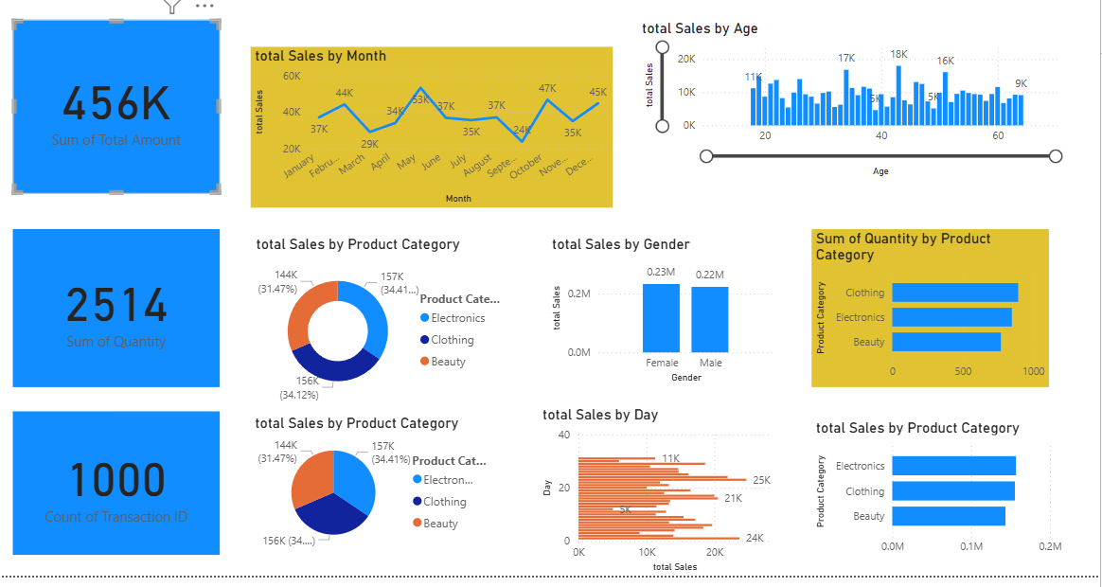 E-Commerce Retail Sales Dashboard Power BI dash Board

Total Sum of Sales getting through by Card Option

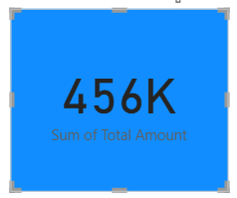

Total Sales by Product Category by bar chart

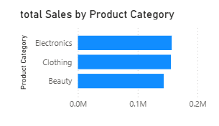

Total Sales By Gender stacked column Chart

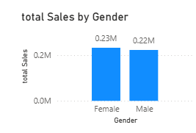

Total Sales by Product Category by donut Chart & Pie Chart

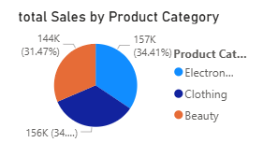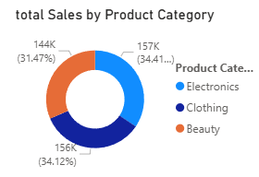

Total Sales by Age Stacked column chart

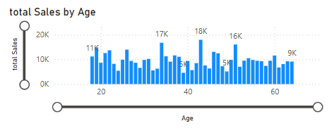

Sum of quantity by Card

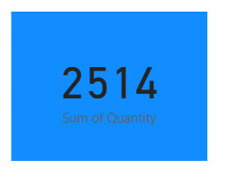

Total Sales by Say stacked Bar Chart

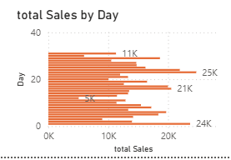

Total sales By Months line chart

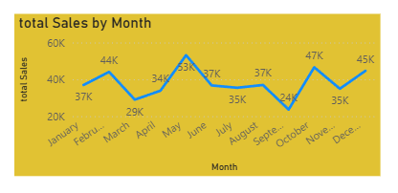

Count of Transaction ID by card

